Reimagining the Ministry of Christian Initiation
Come and See
Ministry Descriptions
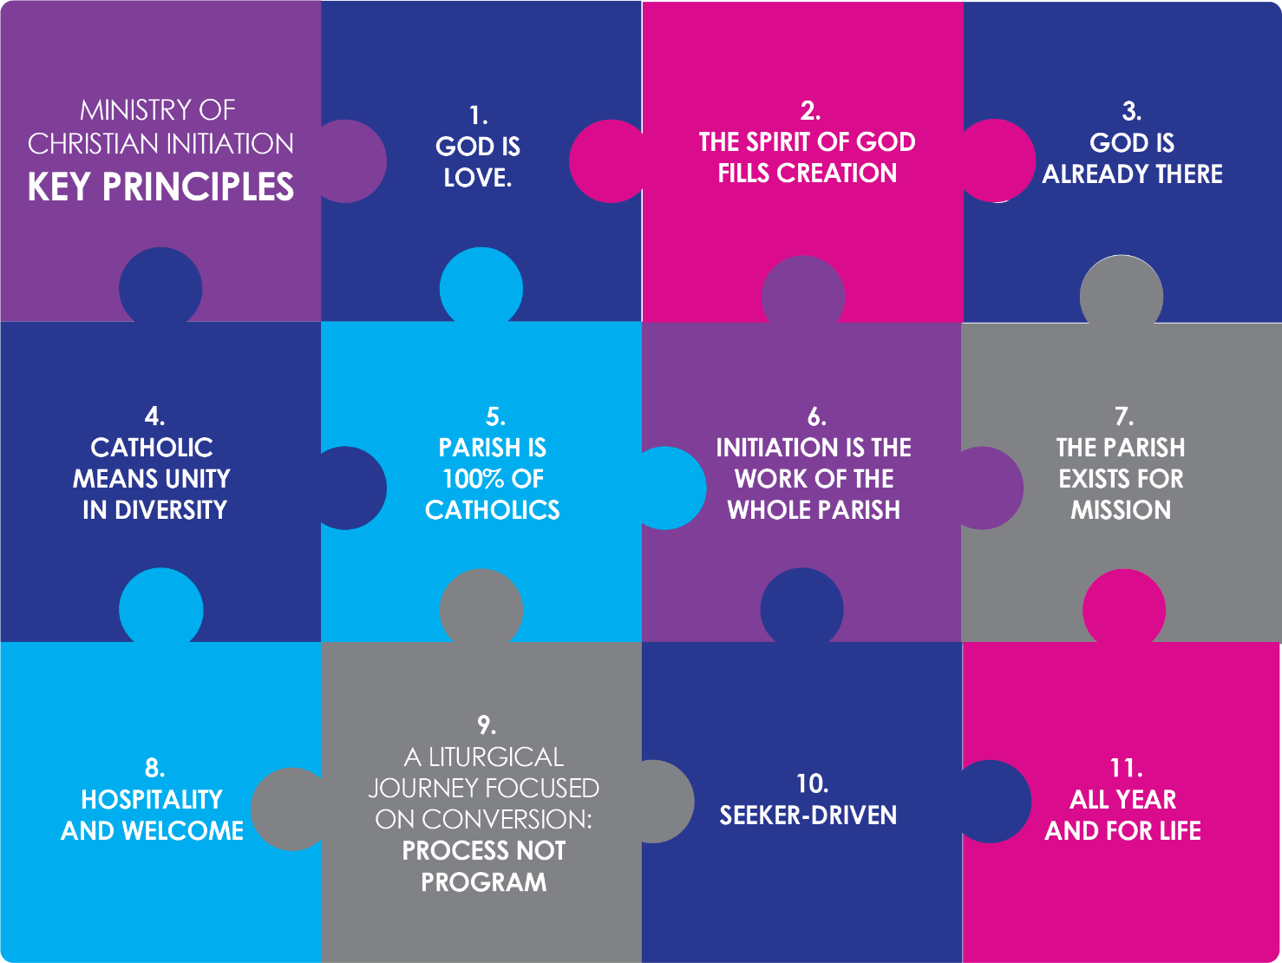

“Those who have opened their hearts to God’s love, heard his voice and received his light, cannot keep this gift to themselves. Since faith is hearing and seeing, it is also handed on as word and light. … The word … spreads to others and invites them to believe… The light of Christ shines …that we too can share in that vision and reflect that light to others. Faith is passed on, we might say, by contact, from one person to another, just as one candle is lighted from another”.

Francis, 2013. Encyclical Letter Lumen Fidei.
Lumen fidei (29 June 2013) | Francis (vatican.va)

`Some steps in the journey [Come and See p. 11]
Focusing on Step 7: Identify and grow communities of
  - potential sponsors. This includes families who can ‘sponsor/accompany’ other families. (See para. 11)
  - people who are happy to have seekers come to their homes for a meal.
  - potential godparents
  - storytellers – members of the faithful who are comfortable sharing their faith.
  - parishioners who would come to Baptisms Outside Mass

The following Ministry Descriptions are offered to support parishes in thinking about how they might reach out to include and actively involve members of the whole community in the ministry of Christian Initiation.
People always want to know: What is involved? What do they have to do? These descriptions are an attempt to provide you with a framework for a response. These can be amended to suit the particular circumstances of individual parishes.
This remains a living document updated in the light of experience.

Whole parish community

… the people of God, as represented by the local Church, should understand and show by their concern that the initiation of adults is the responsibility of all the baptised.3 Therefore the community must always be fully prepared in the pursuit of its apostolic vocation to give help to those who are searching for Christ. In the various circumstances of daily life, even as in the apostolate, all the followers of Christ have the obligation of spreading the faith according to their abilities.4 Hence, the entire community must help the candidates and the catechumens throughout the process of initiation: during the period of the precatechumenate, the period of the catechumenate, the period of purification and enlightenment, and the period of postbaptismal catechesis or mystagogy. [RCIA a 9]
The whole parish, not just a specified team, is charged with responsibility for the ministries of Evangelisation and Initiation.
With regard to Evangelisation, all members of the parish are responsible to:
- proclaim Christ’s message of love in word and deed in the everyday circumstances of life. [cf RCIA a. 9.1, 75]
With regard to the ministry of Christian Initiation – an essential priority of parish life – the whole parish is responsible for:
- embracing ‘the catechumen as its own with a mother’s love and concern,’ [RCIA a 47] and ensuring that they are at the heart of parish life.
- creating opportunities to be invitational [cf RCIA a 9.1]. Catechumens could be invited to attend:
- a parish council meeting.
- a youth ministry meeting.
- special parish events such as feast days.
- community open days.
- local social justice activities associated with organisations such as Catholic Care, Caritas, Catholic Mission.
- the local St Vincent de Paul conference.
- prayer / devotions groups
- reflection days
- Biblical study groups
- Taizé services
- interfaith activities
- arts and crafts opportunities.
- identifying and calling parishioners to various ministries including:
- families who can ‘sponsor/accompany’ other families.
- Sponsors
- Godparents
- storytellers – members of the faithful who are comfortable sharing their faith.
- parishioners who could come to Baptisms Outside Mass and other sacraments of Initiation when they are celebrated in the parish.
- people who are happy to invite seekers to their home for a meal.
      - Offering hospitality.
      - Being interested in the seekers and their journey
      - Sharing their personal experience of living as disciples and members of the church community.
      - Welcoming seekers questions without judgment or criticism.
- being witnesses to the Paschal Mystery and paschal living by:
  - turning more readily to God in prayer.
  - bearing witness to the faith.
  - keeping their hopes set on Christ.
  - practicing love of neighbour.

Storyteller

“In your hearts, set Jesus apart as holy and sovereign. Should anyone ask you the reason for this hope of yours, be ever ready to reply, but to speak gently and respectfully”.
(1 Peter 3:15 IB)

As the precatechumen shares their story and the call they are hearing to live in relationship with God and seek baptism in the Catholic church, so too is the community of faith called to share their stories with them.
Storytelling focused on reflecting on our experiences of God with us, builds up the community of faith at a personal and meaningful level.
Some parishioners will be gifted storytellers who feel comfortable talking about their relationship with God. You will know who they are. All members of the community can grow their capacity for storytelling and faith sharing by:
- thinking about the people who have been significant in their faith journey.
- reflecting on how God, Jesus or the Catholic faith have impacted on you.
- reflecting on moments of joy, recognising God in those times.
- identifying moments of grace when you were aware of the God’s presence.
- identifying significant events or milestones that they are grateful to God for.
Storytelling can focus on and include:
- keeping the faith life of the community part of everyday conversations. It might open the door to further conversations.
- inviting seekers to come along to parish events and sharing the story of why these events are an important part of church/parish life.
- Christian sign and symbols
Storytelling focused on faith sharing helps catechumens discover the many ways God is present with us. By hearing these stories seekers, catechumens and candidates can build on their understanding of what it means to be a member of the Church and begin to reimagine their lives with God at the centre, with them always and everywhere.

Parishes may have many gifted people who use other means of storytelling. These people could include:
- photographers (who can capture those moments where the Spirit is at work within the community)
- videographers (capturing the People of God being people of action)
- writers (that share written stories of faith of the community)
- designers and graphic artists/illustrators (Review and update the parish bulletin and all means of communication by ensuring it is:
- attractive, easy to read and inviting.
- references all the groups, activities, and ministries in the parish and beyond.
- mission focussed.
- reaching as many people as possible.

Sponsor

A sponsor accompanies any candidate seeking admission as a catechumen. Sponsors are persons who have known and assisted the candidates and stand as witnesses to the candidates' moral character, faith, and intention. It may happen that it is not the sponsor for the rite of acceptance and the period of the catechumenate but another person who serves as godparent for the periods of purification and enlightenment and of mystagogy. [RCIA a 10]
There is a distinct difference between a sponsor and a godparent. Being a sponsor is a significant though temporary ministry for the duration of the periods of evangelisation-precatechumenate and catechumenate. Being a godparent is a commitment for life.
Beyond this distinction, the Code of Canon Law uses the term ‘sponsor’ to reference the roles we distinguish as sponsor and godparent.
To be a sponsor is a privilege that is grounded in a diversity of gifts and capacities and is bounded by some requirements that are articulated in detail in the Code of Canon Law c 872-874 and 892-893 regarding confirmation.
- A sponsor must be:
    - fully initiated (Canon 874.1.1,3)
    - a practicing Catholic at least 16 years old. The parish priest may allow a fifteen-year-old to be a sponsor after appropriate conversation and discernment with them. (Canon 874.1.2)
    - be prepared to fulfill the requirements of the ministry.
  - A sponsor is a person:
    - of faith
    - of prayer
    - who participates in the liturgy
    - involved in parish life
    - comfortable talking about their experience of God and their life of faith.
    - with a listening and discerning heart
    - who accepts difference and refrains from judgement.
    - speaks the truth with love and compassion.

The primary role of a sponsor accompanying adult seekers is to:
- be a spiritual friend to the catechumen or baptised candidate.
- share his or her own faith and experience of discipleship.
- be available to accompany the catechumen or candidate for the required period of time. This accompaniment involves inviting and accompanying them to:
    - liturgical celebrations
    - gatherings with other catechumens or candidates
    - various parish and diocesan functions and events
    - experiences of mission outside the church
    - appropriate formation opportunities
- engage in mystagogical reflection on these different experiences helping catechumens and candidates to open their eyes to God’s presence and action in their lives and their hearts to the ongoing call to conversion.
- support the catechumens or candidates ongoing discernment regarding their desire for baptism or full communion.
- rehearse for the various rites that mark the steps of the initiation process. This is something the sponsor does instead of the catechumen/candidate.
The primary role of a sponsor accompanying a child who is to be confirmed is to:
    - be present and fulfil the role at the celebration of confirmation.
Ideally the child’s confirmation sponsor would be their godparent. How might we reimagine the ministry of the sponsor for confirmation?

A sponsor is not:
- the parent of the child who is a candidate for confirmation or the person to be baptised. (Canon 874.1.5).
- a catechist but needs to know who to call on to find answers that the catechumen may have.
- necessarily the godparent for adults.

Godparents

…godparents, members of the Christian community who will assist the candidates at least in the final preparation for baptism and after baptism will help them persevere in the faith and in their lives as Christians. [RCIA a 8]

To be a godparent is a privilege that is grounded in faith and is bound by some requirements.
A godparent must be:
- fully initiated. (Canon 874.1.1,3)
- a practicing Catholic at least 16 years old or one year younger if deemed appropriate by the parish priest, after appropriate conversation and discernment with them (Canon 874.1.2)
- be prepared to fulfill the requirements of the ministry.
A father or mother may not serve as a godparent to their child (Canon 874.1.5).
Generally, a godparent’s role is to:
• be committed for life to the baptised person, actively involved in their life and assisting them to lead a life that is in harmony with their baptismal promise (Canon 872).
- assist the growth of the baptised in his or her spiritual life by:
- fostering a strong relationship.
- sharing his or her own faith.
- being a person of prayer.
- serve as a role model, along with parents in the case of children.
- accompany catechumen/the Elect:
    - on the day of election
    - for the celebration of the Scrutinies
    - for the presentations of the Creed and the Lord’s Prayer
    - for the preparation rite on Holy Saturday
    - at the celebration of the sacraments of initiation, during which and as required they
…testify to the faith of adult candidates or, together with the parents, to profess the Church’s faith, in which children are baptised.’ [RCIA a 9]
    - during the period of mystagogy [RCIA a 11]
For the baptism of a child, one godparent is required, however two may be chosen provided that there is one male and one female. (Canon 873)

Christian witnesses
A baptised Christian from a non-Catholic ecclesial community may be a Christian witness to the baptism only when there is a Catholic godparent. [RCIA a 10.4], (Canon 874.2)

Acknowledgments
Francis, 2013. Encyclical Letter Lumen Fidei of the Supreme Pontiff Francis. 1st Ed. Libreria Editrice Vaticana. Retrieved from Lumen fidei (29 June 2013) | Francis (vatican.va)
Rite of Christian Initiation of Adults. Study Edition. Australia: St Pauls Publication, 1985, ICEL.
The Code of Canon Law. Accessed May 2, 2023. Vatican.va. Code of Canon Law - Book IV - Function of the Church (Cann. 834-878) (vatican.va)
Team RCIA. TeamRCIA – Conversion Happens Here

