Liturgy of the Word
(With Communion)
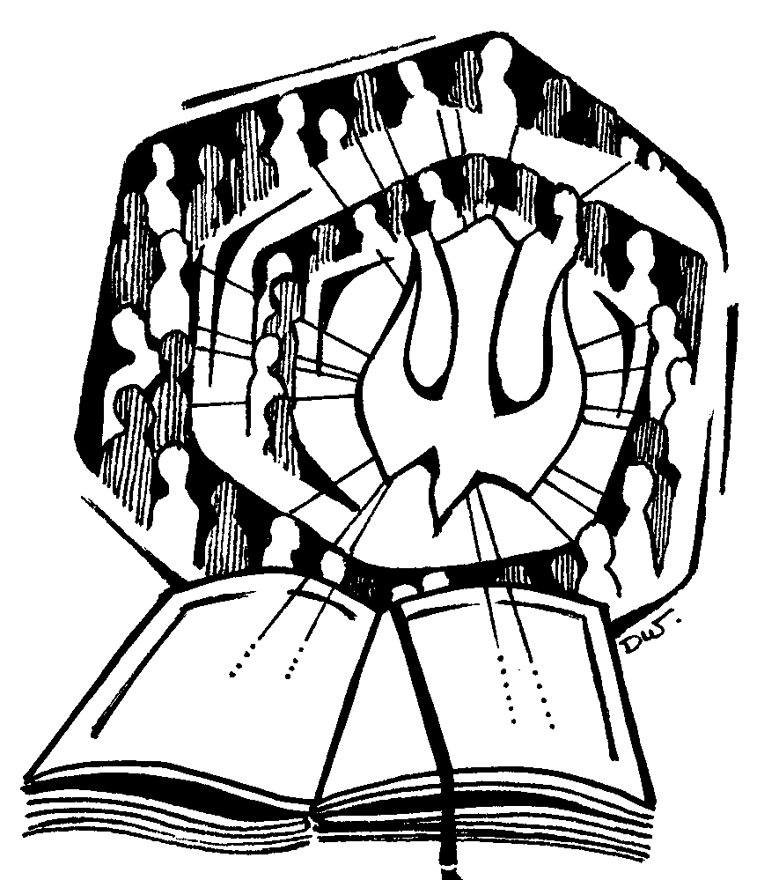

For weekdays

Notes for Lay Leaders
Your main reference for leading a weekday Liturgy of the Word (with Communion) is the ritual book Holy Communion and Worship of the Eucharist Outside Mass and the Lectionary. The Canadian ritual book Sunday Celebrations of the Word and the Hours will also be of some assistance. Both books should be available from the parish. They are also available on LabOra Worship.
You will need to refer to the Ordo to determine the liturgy to be celebrated – that is, the readings and prayers to be used to mark the particular day in the liturgical calendar.
In most cases it is recommended that the ‘Rite for the Distribution of Communion’ NOT be added to a weekday Liturgy of the Word. This is strongly recommended for communities that have regular Sunday Celebrations of the Word with Communion. If for a significant pastoral reason you are including the ‘Rite for the Distribution of Communion’, you will need to arrange for hosts to be available and ensure that these are treated with due respect and care.
The following brief articles might assist you in understanding the recommendations above:
http://liturgybrisbane.net.au/liturgylines/communion-outside-mass-2/
http://liturgybrisbane.net.au/liturgylines/sunday-celebration-of-the-word-with-communion/
If you do proceed with a Liturgy of the Word as recommended ... the structure outlined in this template would be amended as follows:
- The Lord’s Prayer would follow the Sign of Peace as the final element in the ‘Liturgy of the Word’.
- The Concluding Rite would follow on from the Lord’s Prayer as specified.
The structure and elements for this liturgy are outlined in this template. Please note:
- The following template presumes a Lay Leader. Deacons would include the Greeting and other texts appropriate to the ordained.
- Ideally, the altar is stripped bare before the liturgy begins. The corporal is placed on it if Communion is to be given.
- If hymns are being used and words printed anywhere, copyright laws must be followed.
- In this template the Greeting is taken from Sunday Celebrations of the Word and the Hours. Many options are available.
- If there is a communion hymn, care must be taken to ensure the hymn chosen does not suggest that Eucharist is being celebrated.
- Other Blessing options can be found in Sunday Celebrations of the Word and the Hours.
- With regard to the acknowledgements at the end of this template: not all these acknowledgements are required by this template because the readings have not been included. The acknowledgements have been included for your reference. If you prepare a Master Order of Service or a People’s Booklet or PowerPoint, you only make the necessary acknowledgements.
If you require any further assistance please contact the diocesan liturgy office. P: 4979 1135
E: louise.gannon@mn.catholic.org,au

The Introductory Rites
Entrance Antiphon or Hymn
The Assembly gathers. The Lay Leader is seated in a suitable place so that s/he is able to lead the liturgy effectively.
When all is ready the Assembly stands and reads the Entrance Antiphon or sings an appropriate hymn.
Insert the Antiphon or hymn here.
Introductory Remarks
Use the following or similar word as appropriate.
Leader: We gather today, __________ (in this sixteenth week of Ordinary Time), to listen and respond to God’s Word (and to receive communion).
My name is __________ and I have been commissioned/asked by _______ (name the parish priest/Moderator/Community Leader) to lead today’s liturgy.
Greeting
Leader: In the name of the Father, and of the Son, and of the Holy Spirit.
All: Amen.
Leader: Blessed be God,
who enables us, through the Spirit.
Bless the Father and the Son and the Holy Spirit.
All: Blessed be God for ever.
Penitential Act
Any of the options from the Missal may be used.
Leader: Lord have mercy
All: Lord have mercy
Leader: Christ have mercy
All: Christ have mercy
Leader: Lord have mercy
All: Lord have mercy
Leader: May almighty God have mercy on us,
forgive us our sins,
and bring us to everlasting life.
All: Amen.
Collect
The Leader uses the Collect (Opening Prayer) from the Mass of the day. Ensure that the prayer does not state or infer that Eucharist is to be celebrated. If the prayer does indicate this, then amend the words accordingly.
Please be seated at the conclusion of the Collect.

The Liturgy of the Word
The Liturgy of the Word is celebrated as usual, using the readings of the day from the Lectionary.
First Reading
After the reading, pause for quiet reflection.
Responsorial Psalm:
After the Psalm, pause for quiet reflection.
Gospel Acclamation Please stand
Gospel
Reader: A reading from the Holy Gospel according to ...
All: Glory to you O Lord.
Reflection Please be seated
The Assembly sits quietly to reflect on the readings. Depending on the nature of the gathering, the Leader or someone else may share a few thoughts on the readings or space might be left for anyone to share a reflection. This quiet reflection time can flow easily into a time for prayer in the Universal Prayer which follows.
The Universal Prayer Please stand
The Universal Prayer (Prayer of the Faithful) is not normally a part of weekday liturgy but may be included. If so it may be prepared by the community, or taken from the Appendix in the Missal or the Prayer of the Church for the day.
Sign of Peace

Rite for the Distribution of Communion
Bringing the Blessed Sacrament to the Altar
The Assembly remains standing as the Leader (or another minister if the Tabernacle is at some distance from the Altar) goes to the Tabernacle, takes the ciborium or pyx containing the body of the Lord, and brings it to the altar, placing it on the corporal.
The Leader then introduces the Lord’s Prayer.
The Lord’s Prayer
Leader: Taught by the Saviour’s command
and formed by the Word of God,
we dare to say:
The Leader and the Assembly pray together
All: Our Father, who art in heaven,
hallowed be thy name;
thy kingdom come,
thy will be done
on earth as it is in heaven.
Give us this day our daily bread,
and forgive us our trespasses,
as we forgive those who trespass against us;
and lead us not into temptation,
but deliver us from evil.
For the kingdom, the power and the glory are yours
now and forever. Amen.
Please kneel at the conclusion of the Lord’s Prayer.
Invitation to Communion
The Leader genuflects, takes a host, raises it slightly and says aloud …
Leader: Behold the Lamb of God,
behold him who takes away the sins of the world.
Blessed are those called to the supper of the Lamb.
All: Lord, I am not worthy
that you should enter under my roof,
but only say the word
and my soul shall be healed.
If there is a communion hymn it begins now. Alternatively, the Communion Antiphon may be said if it is appropriately worded.
The Minister receives communion, saying quietly, ‘May the body of Christ bring me everlasting life.’ The Minister then gives communion to any additional communion ministers. They then go to their stations and the faithful come forward to receive communion.
Reposition of the Blessed Sacrament
Once communion is complete, the Blessed Sacrament is returned to the tabernacle, the altar is cleared, and the vessels are cleaned.
After communion, a period of silence is observed.
Prayer after Communion Please stand
The Leader uses the prayer from the Mass of the day. Ensure that it does not state or infer that Eucharist has been celebrated. If the prayer does indicate this, then amend the words accordingly.
The Concluding Rites
Blessing
At the appropriate time during the blessing, the leader makes the sign of the cross.
Leader: May the almighty and merciful God bless and protect us,
the Father, and the Son,
and the Holy Spirit
All: Amen.
Dismissal
Leader: Go and announce the Gospel of the Lord.
All: Thanks be to God.

Acknowledgement
Text Excerpts from the English translation of The Roman Missal © 2010, International Commission on English in the Liturgy Corporation. All rights reserved.
The English translation of the Holy Communion and Worship of the Eucharist outside Mass approved for use in Australia and New Zealand was prepared by the International Commission on English in the Liturgy. All rights reserved.
Text Excerpts from Sunday Celebration of the Word and Hours Canadian Conference of Catholic Bishops, Ottawa, © 1995, Concacan Inc. All rights reserved.
The Scripture quotations contained herein are from The Jerusalem Bible © 1966 by Darton, Longman & Todd Ltd and Doubleday and Company Ltd, and used with permission of the publishers. NB. This acknowledgement is only retained if the scriptures are printed.
Cover Image: Dorothy Woodward rsj. Used with permission in the Diocese of Maitland-Newcastle

