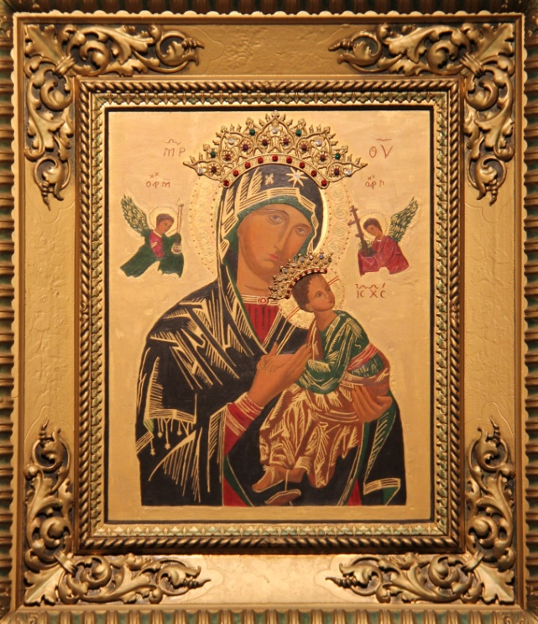

Solemnity of
Our Lady of Perpetual Help
Patron of the Church of Maitland-Newcastle

June 27
MASS and LITURGY TEXTS
The title Our Lady of Perpetual Help (also known as the Virgin of the Passion) came to prominence when in 1866 Pius IX entrusted the icon, then newly discovered, to the Redemptorists.
The icon shows four holy figures: the Virgin Mother of God, the Christ Child and the Archangels Michael and Gabriel. Mary is shown looking away from her Son to ourselves, ready to help us in time of need. Mary is showing her Son to us, directing us to Jesus the Word who liberates us through his suffering and death. Mary is the faithful disciple, ever open to the Word of God in her life.
For further information about the icon see https://cssr.org.au/perth/our-lady-of-perpetual-help/.
Our Lady of Perpetual Help, as the patron of our ‘Particular Church’, is celebrated in our diocese June 27, and in the diocese has the ranking of an obligatory Solemnity which includes First Vespers. In the Table of Precedence it ranks above Sundays of Ordinary Time.
The readings chosen for our diocese have been taken from ‘The Common for the Blessed Virgin Mary’ - Lectionary II p. 1357 ff. The various texts have been chosen and, in some cases, slightly adapted from:
- Votive Masses for the Blessed Virgin Mary – Missal.
Option B Our Lady, Mother of the Church p. 1411 ff.
- Mass for Various Needs and Occasions, E For the Particular Church – Missal p. 1303.
This selection has been made with respect to a range of formats that has existed in the diocese over some years. They are recommended for your use from 2014.
Yours sincerely,
The Diocesan Liturgy Council
June 13, 2014
Updated June 24, 2019 and June 23, 2021.

Introductory Rite
Entrance Antiphon
There by the cross of Jesus stood his mother, the sister of his mother,
Mary the wife of Cleophas, and Mary Magdalene. [Jn 19:25]
Gloria (Sung)
Collect
[Option 1 based on Mass for the Holy Church – E (For the Particular Church) p. 1302]
Presider: O God, who in each pilgrim Church throughout the world
make visible the one, holy catholic and apostolic Church,
graciously grant
that your faithful of the Church of Maitland-Newcastle,
in celebrating the Patronage of our Mother of Perpetual Help,
and gathered as one through the Gospel and the Eucharist,
may worthily be a sign and instrument
of the Presence in the world
of Christ our Lord.
Who lives and reigns with you in the unity of the Holy Spirit,
one God, forever and ever.
All: Amen.
(Option 2 – Local composition primarily for use in Liturgies of the Word which may be the form a celebration in schools)
Presider: Lord our God,
in the Blessed Virgin Mary, Mother of Perpetual Help,
Patron of the Church of Maitland-Newcastle;
You have shown us a disciple who is faithful to your Word.
Open our hearts to receive your saving word,
so that, by the power of your Holy Spirit,
it may direct our daily living to bring forth a rich harvest of holiness.
We pray through our Lord Jesus Christ, your Son,
Who lives and reigns with you, in the unity of the Holy Spirit,
One God, forever and ever.
All: Amen.
Liturgy of the Word
Old Testament Options
A reading from the book of Ecclesiasticus (24: 1, 3-4, 8-12, 19-22)
(Lectionary II Reading 6, p. 1363)
Wisdom speaks her own praises,
in the midst of her people she glories in herself.
'I came forth from the mouth of the Most High,
and I covered the earth like mist.
I had my tent in the heights,
and my throne in a pillar of cloud.
Then the creator of all things instructed me,
and he who created me fixed a place for my tent.
He said, "Pitch your tent in Jacob,
make Israel your inheritance."
From eternity, in the beginning, he created me,
and for eternity I shall remain
I ministered before him in the holy tabernacle,
and thus was I established on Zion.
In the beloved city he has given me rest,
and in Jerusalem I wield my authority.
I have taken root in a privileged people
in the Lord's property, in his inheritance.
Approach me, you who desire me,
and take your fill of my fruits,
for memories of me are sweeter than honey,
inheriting me is sweeter than the honeycomb.
They who eat me will hunger for more,
they who drink me will thirst for more.
Whoever listens to me will never have to blush,
whoever acts as I dictate will never sin.'
The word of the Lord.
All: Thanks be to God.
OR
A reading from the book of Proverbs (8: 22-31)
(Lectionary II Reading 5, p. 1362)
The Wisdom of God cries aloud:
The Lord created me when his purpose first unfolded,
before the oldest of his works.
From everlasting I was firmly set,
from the beginning, before earth came into being.
The deep was not, when I was born,
there were no springs to gush with water.
Before the mountains were settled,
before the hills, I came to birth;
before he made the earth, the countryside,
or the first grains of the world's dust.
When he fixed the heavens firm, I was there,
when he drew a ring on the surface of the deep,
when he thickened the clouds above,
when he fixed fast the springs of the deep,
when he assigned the sea its boundaries
- and the waters will not invade the shore -
when he laid down the foundations of the earth,
I was by his side, a master craftsman,
delighting him day after day,
ever at play in his presence,
at play everywhere in his world,
delighting to be with the sons of men.
The word of the Lord.
All: Thanks be to God.
Responsorial Psalm
I Sam 2: 1, 4- 8
(Lectionary II following Reading 7, p. 1364-1365)
R. My heart rejoices in the Lord, my Saviour.
My heart exults in the Lord,
I find my strength in my God;
my mouth laughs at my enemies
as I rejoice in your saving help. R.
The bows of the mighty are broken,
but the weak are clothed with strength.
Those with plenty must labour for bread,
but the hungry need work no more.
The childless wife has children now
but the fruitful wife bears no more. R.
It is the Lord who gives life and death,
he brings men to the grave and back;
it is the Lord who gives poverty and riches.
He brings men low and raises them on high. R.
He lifts up the lowly from the dust,
from the dung heap he raises the poor
to set him in the company of princes,
to give him a glorious throne. R.
New Testament Option
A reading from the Acts of the Apostles (1:12-14)
(Lectionary II Reading 1, p. 1370)
After Jesus had ascended into heaven, the apostles went back to Jerusalem, a short distance away, no more than a Sabbath walk; and when they reached the city they went to the upper room where they were staying; there were Peter and John, James and Andrew, Philip and Thomas, Bartholomew and Matthew, James, son of Alphaeus and Simon the Zealot, and Jude, son of James. All these joined in continuous prayer, together with some women, including Mary the mother of Jesus, and with his brothers.
The word of the Lord.
All: Thanks be to God.
Gospel Acclamation
(Lectionary II, prior to the 7th Gospel, p. 1363)
Alleluia! Alleluia!
Blessed is the Virgin Mary
Who kept the word of God and pondered it in her heart.
Alleluia!
Gospel
A reading from the holy Gospel according to John (19: 25- 27)
(Lectionary II, no 12, p. 1385)
Near the cross of Jesus stood his mother and his mother's sister, Mary the wife of Cleopas, and Mary of Magdala. Seeing his mother and the disciple he loved standing near her, Jesus said to his mother, 'Woman, this is your son'. Then to the disciple he said, 'This is your mother.' And from that moment the disciple made a place for her in his home.
The Gospel of the Lord.
All: Praise to you, Lord Jesus Christ.
Creed
Universal Prayer (Prayer of the Faithful)
The following prayer provides a sample template that might assist you in composing your own intentions for prayer.
Presider: We invoke the intercession of Mary our Mother of Perpetual Help, as we bring our prayers to the Living God.
Reader: We pray for our Church of Maitland-Newcastle:
That devotion to our Patron, Mary of Perpetual Help, will inspire that fidelity to the Gospel which brings joy and peace to all. We pray ...
All: Lord hear our prayer.
We pray for the people who live in this Hunter-Manning region:
That…
We pray ....
All: Lord hear our prayer.
We pray for .... those who struggle with any infirmity – of body or spirit, family disruption, or employment difficulties:
That…
We pray …
All: Lord hear our prayer.
We pray for ...
That…
We pray …
All: Lord hear our prayer.
We pray for the deceased members of our community:
that they may eternally dwell in God Who is Life.
We pray …
All: Lord hear our prayer.
Presider: Let us all pray:
All powerful God our Father,
aided by the prayer of our Mother of Perpetual Help,
may we come to know you, the only true God
and Jesus Christ whom you have sent;
Who lives and reigns for ever.
All: Amen.
Liturgy of the Eucharist
Prayer over the Offerings Missal p. 1412
Presider: Pray, brethren (brothers and sisters),
that my sacrifice and yours
may be acceptable to God,
the almighty Father.
All: May the Lord accept the sacrifice at your hands
for the praise and glory of his name,
for our good
and the good of all his holy Church.
Presider: Receive our offerings, O Lord,
and transform them into the mystery of salvation,
so that by its power we may be set aflame
with the charity of the Virgin Mary, Mother of Perpetual Help,
and with her may be united more closely
to the work of redemption.
Through Christ our Lord.
All: Amen.
Preface
Missal p 1412/1414 (this could not be found on LabOra)
Presider: The Lord be with you.
All: And with your spirit.
Presider: Lift up your hearts.
All: We lift them up to the Lord.
Presider: Let us give thanks to the Lord our God.
All: It is right and just.
Presider: It is truly right and just, our duty and our salvation,
always and everywhere to give you thanks,
Lord, holy Father, almighty and eternal God,
and to proclaim your greatness with due praise,
as we celebrate the Solemnity of Our Lady of Perpetual Help.
Receiving your Word in her Immaculate Heart,
she was found worthy to conceive him in her virgin’s womb
and giving birth to the creator,
she nurtured the beginnings of the Church.
Standing beside the cross,
She received the testament of divine love
And took to herself as sons and daughters
All those who by the death of Christ
are born to heavenly life.
As the Apostles awaited the Spirit you had promised,
She joined her supplication to the prayers of the disciples
And so became the pattern of the Church at prayer.
Raised to the glory of heaven,
She accompanies your pilgrim Church with a mother’s love
And watches in kindness over the Church’s homeward steps,
Until the Lord’s day shall come in glorious splendour.
And so with the Angels and Saints
we praise you as without end we acclaim:
Communion Antiphon
(Missal p. 1415 – second option)
As he hung upon the cross,
Jesus said to the disciple whom he loved: Behold your mother. [Jn 19:27]
Prayer after Communion
(Option C, Missal p. 1416)
Presider: Let us pray.
Grant O Lord,
To us whom you have strengthened at the table of word
and Sacrament,
that, with Blessed Mary as our patron and guide,
we may reject whatever is contrary to the name of Christian
and follow whatever accords with it.
Through Christ our Lord.
All: Amen.

Concluding Rite
Solemn Blessing
(Solemn Blessings at the end of Mass. Missal p. 717)
Presider: May God, who through the motherhood of the Virgin Mary
graciously redeemed the human race,
enrich you and all the diocese with his blessing.
All: Amen.
Presider: Through Mary you have received the author of life.
May you experience her loving and perpetual help
now and at every hour.
All: Amen.
Presider: You have gathered to celebrate
our Patronal feast of Our Lady of Perpetual Help.
May you go forth from here
rejoicing in the Spirit and gifts of heaven.
All: Amen.
Presider: May almighty God bless all of you who are gathered here,
the Father, and the Son, and the Holy Spirit.
All: Amen.

Acknowledgement
Text Excerpts from the English translation of The Roman Missal © 2010, International Commission on English in the Liturgy Corporation. All rights reserved.
The Scripture quotations contained herein are from The Jerusalem Bible © 1966 by Darton, Longman & Todd Ltd and Doubleday and Company Ltd, and used with permission of the publishers.
The Grail (Psalms and canticles from the lectionary and liturgy of the hours): Psalm texts from The Psalms: A New Translation © 1963 The Grail (England), published by HarperCollins, and used by permission of the publishers.
Photograph of image of Our Lady of Perpetual Help which hangs in the Sacred Heart Cathedral, a gift to the Cathedral from the Redemptorist Fathers when they closed the Monastery at Mayfield. Used with permission.

